Customer Segmentation Machine Learning Project

LaChandra Ash

**Summary**

Client wanted the best customers to come and buy their products. A machine learning application was created in R programming language to gain a deeper understanding of customer preferences as well as the requirements for discovering valuable segments that would reap them maximum profit. This way, they can strategize their marketing techniques more efficiently and minimize the possibility of risk to their investment.

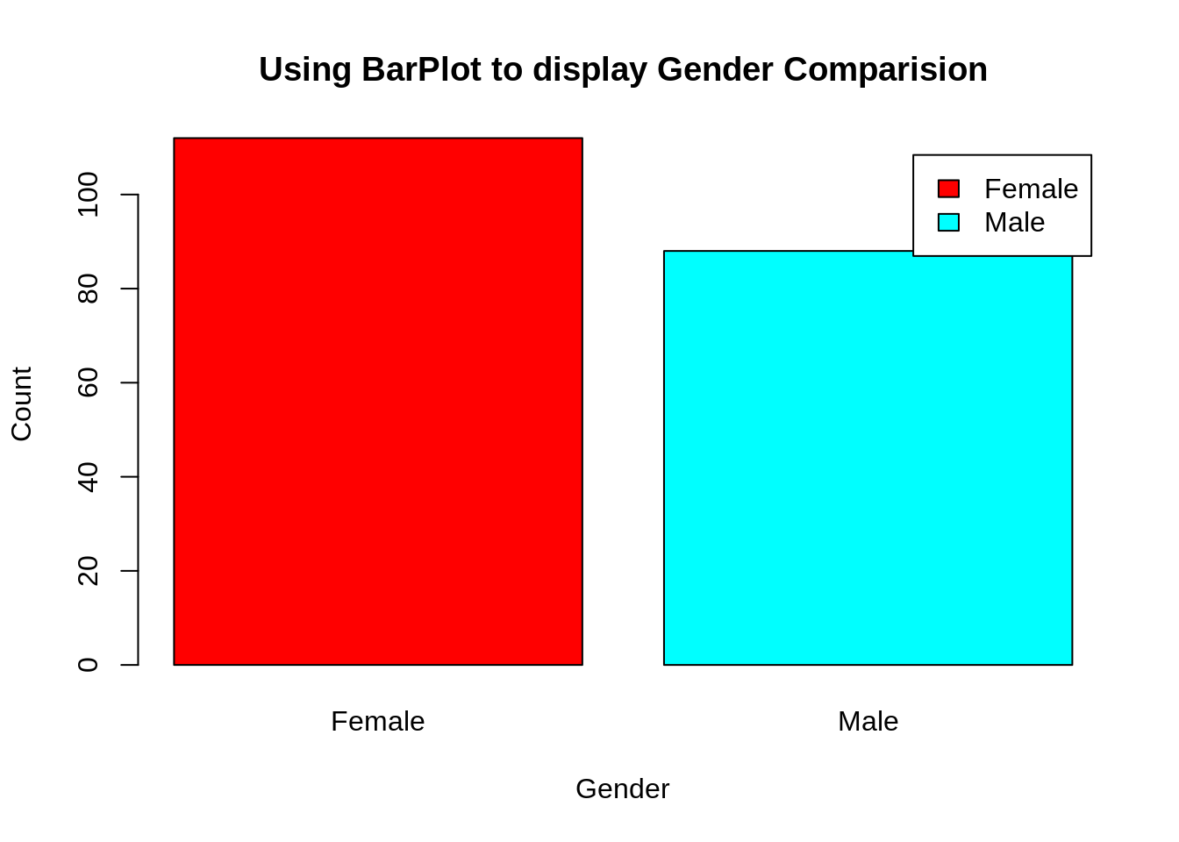

From the above barplot, I observed that the number of females is higher than the males. Now, let’s visualize a pie chart to observe the ratio of male and female distribution.

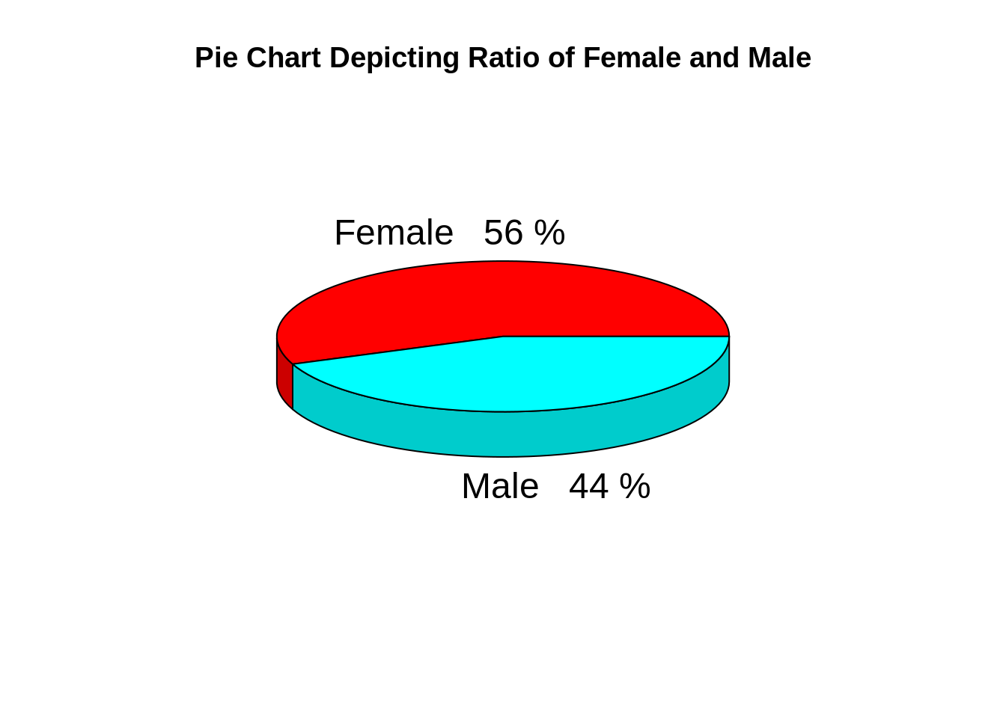

From the above graph, I conclude that the percentage of females is **56%**, whereas the percentage of male in the customer dataset is **44%**.

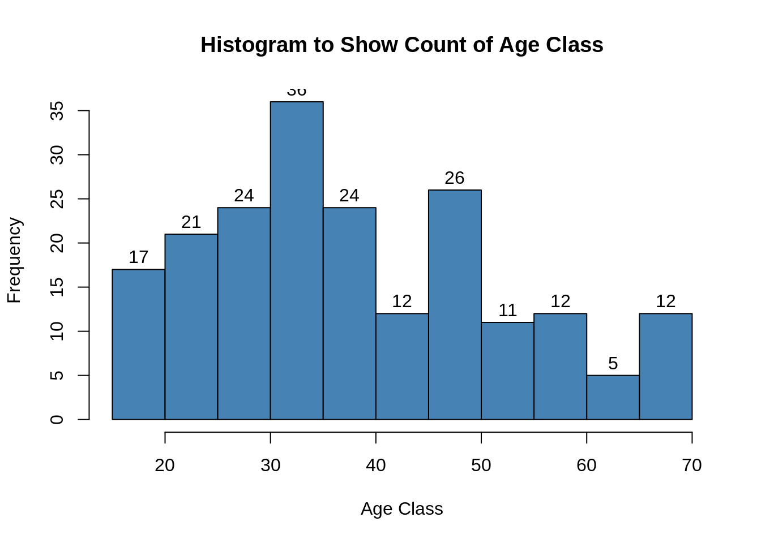

The above histogram displays the frequency of customers’ ages.

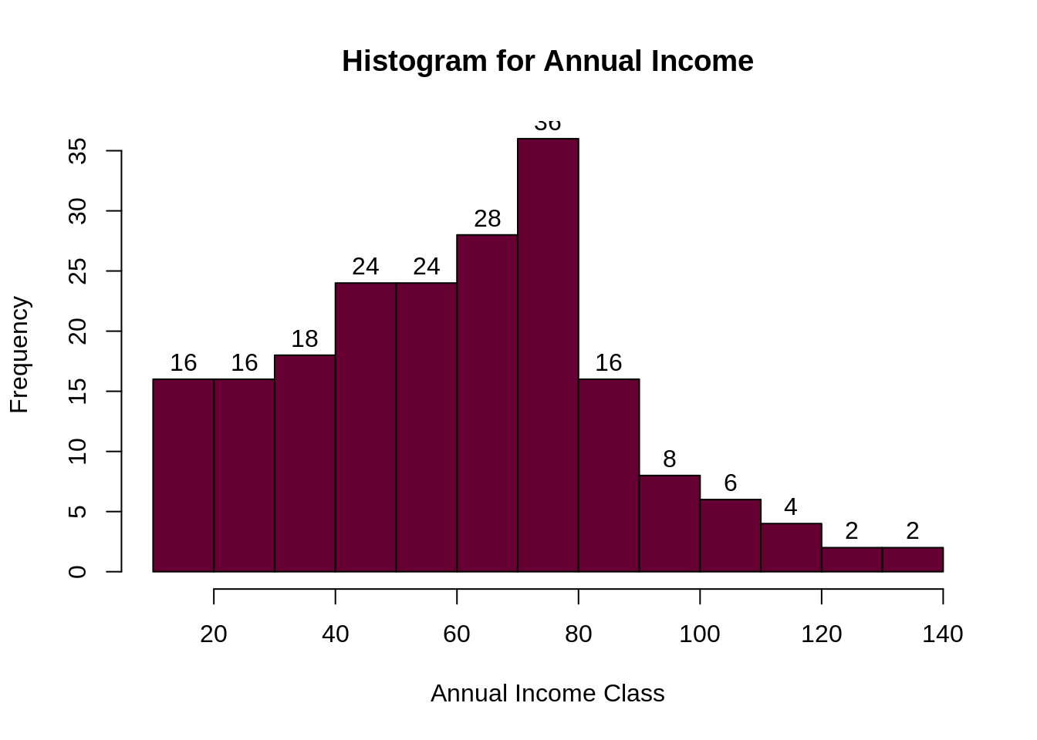

The histogram above displays the customers’ annual income.

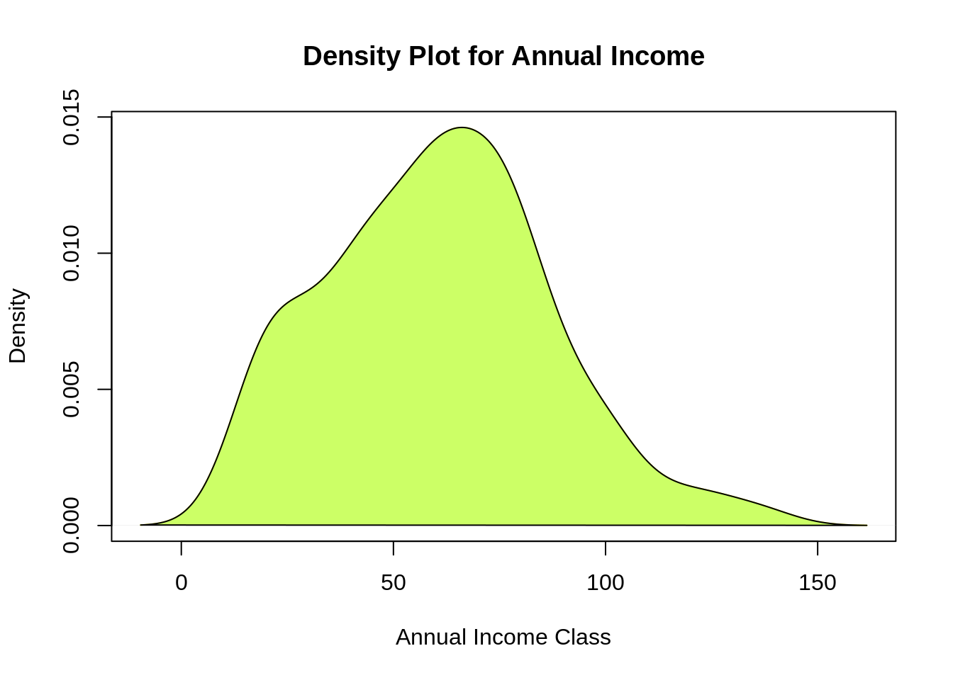

From the above descriptive analysis, I conclude that the minimum annual income of the customers is 15 and the maximum income is 137. People earning an average income of 70 have the highest frequency count in the histogram distribution. The average salary of all the customers is 60.56.

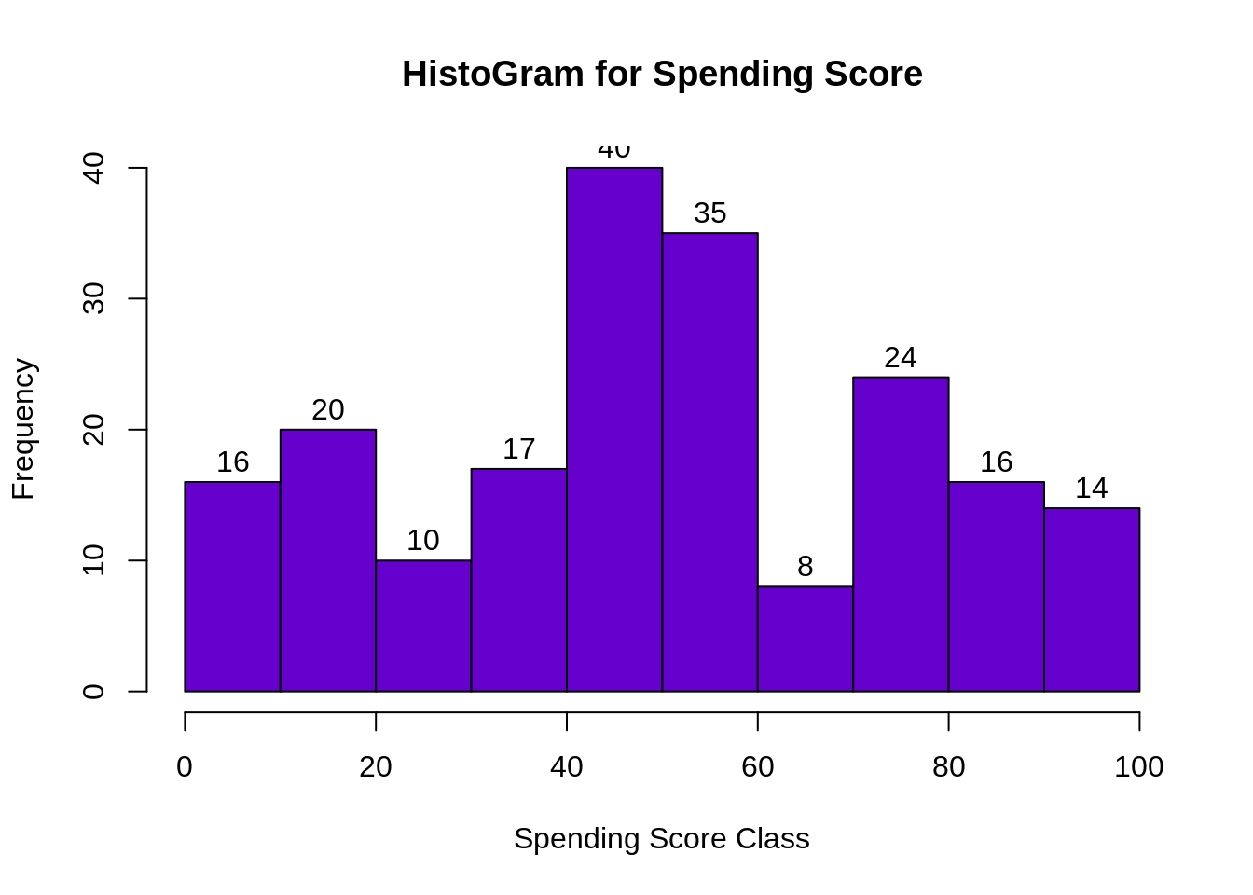

The minimum spending score is 1, maximum is 99 and the average is 50.20. We can see Descriptive Analysis of Spending Score is that Min is 1, Max is 99 and avg. is 50.20. From the histogram, I conclude that customers between class 40 and 50 have the highest spending score among all the classes.

Conclusion

With the identification of customers, the client can release products and services that target customers based on several parameters like income, age, spending patterns, etc. Furthermore, more complex patterns like product reviews are taken into consideration for better segmentation.